TZ Media Connect: Centralized Government Media Reviewing and Distribution System

Problem statement
In the Tanzanian art community, content creators, including musicians, filmmakers, authors, and scriptwriters, face significant challenges in obtaining approval for their artistic works from the regulatory body, Baraza la Sanaa Tanzania (BASATA). The existing process for content approval is often cumbersome, lacks efficiency, and is prone to inconsistencies. The lack of centralized system has resulted in delays, frustrations, and sometimes even the rejection of content that may adhere to the required standards but fails to navigate the bureaucratic hurdles effectively. Moreover, there is a pressing need for a systematic approach to monitor and control the dissemination of artistic content to the public. Unauthorized sharing of content without BASATA's approval poses a challenge in maintaining the integrity of the art industry and ensuring that only culturally acceptable and legally compliant works reach the audience.
Proposed solution
To address the above problem I propose the solution that involves the development of an accessible and streamlined Content Management and Approval System tailored for Baraza la Sanaa Tanzania (BASATA). This system will offer a user-friendly online platform for artists to register, manage their profiles as well as submit their music, films, books, and scripts, hence simplifying the submission process. It will incorporate a robust review panel management module to facilitate content evaluation, feedback, and decision-making by government authorities and approve the content. Upon approval, an automated code (unit identification number) will be generated for each piece of content, serving as a reference for verification. The system will include monitoring features to detect unauthorized sharing in which the system will adopt, ensuring content compliance. Enhanced user authentication and data security measures will be implemented, accompanied by comprehensive training resources for users, while comprehensive reporting and analytics capabilities will provide valuable insights on system performance and content management

Here is a breakdown of the key components from the proposed solution:
Integrated Platform: Create a centralized platform that connects all artists, government authorities, and media channels. This platform serves as a hub for all content-related processes.
User Registration and Profile Management: Allow artists to create accounts and manage their profiles, including personal details, contact information, and portfolios.
Content Submission and Review: Enable artists to submit their content for review and verification, supporting various media types and attaching relevant documentation and descriptions.
Review Panel Management: Develop a system to manage the review panel responsible for evaluating submitted content. Panel members can access and review content, provide feedback, and make decisions based on predefined criteria.
Licensing and Certification: Create a module for managing licenses and certifications for approved content, ensuring compliance with copyright laws and content quality standards.
Content Rating and Classification: Implement a module for categorizing and labeling approved content based on predefined rating systems, ensuring appropriate classification for different media channels and target audiences.
Reporting and Analytics: Incorporate a module for generating insights and tracking system performance, providing statistical data on content submissions, approval rates, and user feedback.
Administration and Security: Implement robust administrative features to manage user accounts, permissions, and system configurations. Adhere to strict security protocols to protect sensitive data and prevent unauthorized access.
Integration with Media Channels: Enable seamless integration with public media channels such as radios, TV stations, and social media platforms. Automatically distribute approved content to reach wider audiences.
Documentation and Support: Provide comprehensive documentation and user support resources, including training programs and a dedicated support team, to assist artists, musicians, and administrators in using the platform.

Technology stack
Front-end: React
Back-end: Node.js
Database: MySQL
Notification Service: Using SMS for notifications
API: Integration and distribution system

Use case diagram
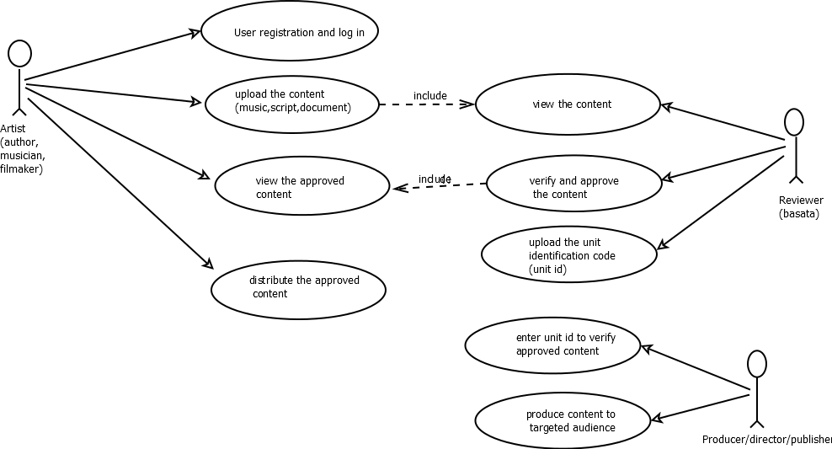

Title: TZ Media Connect: Centralized Government Media Reviewing and Distribution System
Date: March 2, 2024

1. Introduction
The TZ Media Connect project aims to address the challenges faced by content creators in the Tanzanian art community by developing a centralized Content Management and Approval System for Baraza la Sanaa Tanzania (BASATA). This system will streamline the content approval process, enhance efficiency, and ensure that only culturally acceptable and legally compliant works reach the audience. This report provides a comprehensive overview of the proposed solution, its key components, and the expected benefits.

2. Problem Statement
The existing content approval process in the Tanzanian art community is cumbersome, inefficient, and prone to inconsistencies. Content creators face challenges in obtaining approval for their artistic works from BASATA, leading to delays, frustrations, and rejections. The lack of a centralized system also makes it difficult to monitor and control the dissemination of artistic content, resulting in unauthorized sharing and potential damage to the integrity of the art industry.

3. Proposed Solution
The proposed solution involves the development of a Content Management and Approval System specifically designed for BASATA. The key components of the system are as follows:

3.1 Integrated Platform
A centralized platform will be created to connect artists, government authorities, and media channels. This platform will serve as a hub for all content-related processes, providing a seamless and efficient workflow.

3.2 User Registration and Profile Management
Artists will be able to create accounts and manage their profiles on the platform. This feature will allow them to provide personal details, contact information, and showcase their portfolios.

3.3 Content Submission and Review
The system will enable artists to submit their content for review and verification. It will support various media types, allowing artists to attach relevant documentation and descriptions to enhance the review process.

3.4 Review Panel Management
A system will be developed to manage the review panel responsible for evaluating submitted content. Panel members will have access to the platform, where they can review content, provide feedback, and make decisions based on predefined criteria.

3.5 Licensing and Certification
The system will include a module for managing licenses and certifications for approved content. This feature will ensure compliance with copyright laws and content quality standards.

3.6 Content Rating and Classification
A module will be implemented to categorize and label approved content based on predefined rating systems. This will enable appropriate classification for different media channels and target audiences.

3.7 Reporting and Analytics
The system will provide a reporting and analytics module to generate insights and track system performance. It will offer statistical data on content submissions, approval rates, and user feedback, assisting in decision-making and system optimization.

3.8 Administration and Security
Robust administrative features will be implemented to manage user accounts, permissions, and system configurations. Strict security protocols will be followed to protect sensitive data and prevent unauthorized access.

3.9 Integration with Media Channels
The system will seamlessly integrate with public media channels such as radios, TV stations, and social media platforms. Approved content will be automatically distributed to reach wider audiences.

3.10 Documentation and Support
Comprehensive documentation and user support resources, including training programs and a dedicated support team, will be provided to assist artists, musicians, and administrators in using the platform effectively.

4. Benefits
The TZ Media Connect system is expected to bring several benefits, including:

- Streamlined content approval process, reducing delays and frustrations for content creators.
- Enhanced efficiency and consistency in content evaluation and decision-making.
- Improved control and monitoring of content dissemination, ensuring compliance with cultural and legal standards.
- Protection of artists' intellectual property rights through licensing and certification mechanisms.
- Increased transparency and accountability in the content approval process.
- Access to valuable insights and analytics for system optimization and decision-making.
- Enhanced collaboration and communication between artists, government authorities, and media channels.
- Improved public access to culturally acceptable and legally compliant artistic works.

5. Conclusion
The TZ Media Connect project proposes a centralized Content Management and Approval System to address the challenges faced by content creators in the Tanzanian art community. By streamlining the content approval process, enhancing efficiency, and ensuring compliance with cultural and legal standards, the system is expected to bring significant benefits to artists, government authorities, and the general public.
Stakeholder | Role | Interests | Influence
Artists and Content Creators | Primary users | Streamlined submission process, transparent review and approval, wider audience reach, protection of intellectual property rights | High
Baraza la Sanaa Tanzania (BASATA) | Regulatory body | Efficient and standardized content approval process, monitoring and control of artistic content, adherence to cultural standards and legal compliance | High
Media Channels | Distribution platforms | Access to quality and culturally acceptable content, streamlined integration with the Content Management and Approval System | Medium
Audiences | Consumers | Access to a wide range of approved and culturally acceptable content | Medium
Copyright Organizations | Intellectual property protection | Proper licensing and certification of approved content, prevention of unauthorized sharing and piracy | Medium
Legal Authorities | Legal compliance | Adherence to legal requirements, prevention of illegal content dissemination | Medium

Stakeholder | Role | Interests | Influence
Artists and Content Creators | Primary users and providers of content | Efficient content submission process, transparent review and approval, protection of intellectual property rights, wider audience reach | High
Baraza la Sanaa Tanzania (BASATA) | Regulatory body | Standardized content approval process, adherence to cultural standards and legal compliance, monitoring and control of artistic content | High
Media Channels | Distribution platforms | Access to quality and culturally acceptable content, seamless integration with the Content Management and Approval System | Medium
Audiences | Consumers | Access to a wide range of approved and culturally acceptable content | Medium
Copyright Organizations | Intellectual property protection | Proper licensing and certification of approved content, prevention of unauthorized sharing and piracy | Medium
Legal Authorities | Legal compliance | Adherence to legal requirements, prevention of illegal content dissemination | Medium

